Stephen Laycock  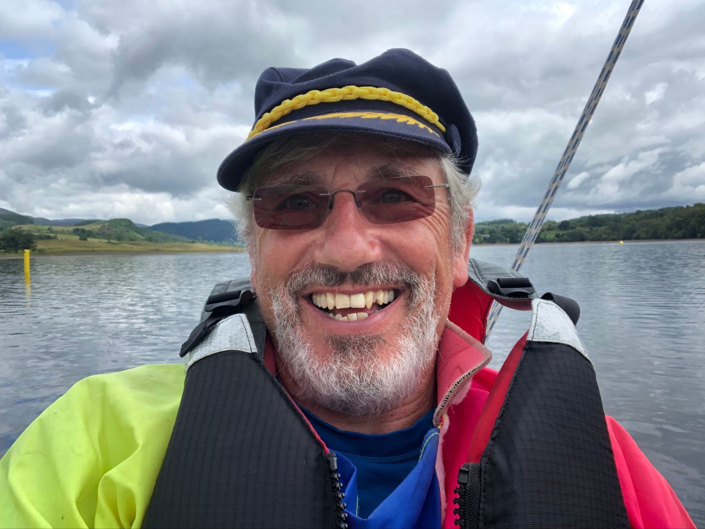  chairman@sailabilityscotland.org.uk  www.sailabilityscotland.org.uk | 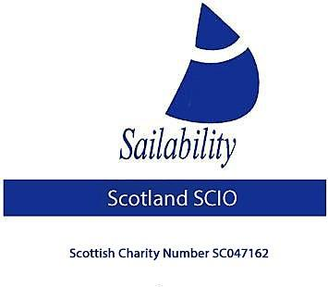
Tick Tack for 23rd August 2022
A lot has been happening recently and so I thought I would try and put all the info into one document
Firstly many apologies to one and all for the very late cancelation of the T5 regatta which should have been held on 13/14 August at Bardowie. The reason for the cancellation is unclear but at the end of the day there was a lack of effective communication and I take responsibility for that.
The good news is that CCSC (Bardowie) Acting Commodore (Hugh McLean) has offered to put the event back into their calendar on the 15/16 October. He will have to secure race officers and shore/safety boat crew for this event so can anyone who wishes to go PLEASE complete an entry form ASAP. Or at the very least let me know you would like to participate in the event.
As I write (Tuesday 23 August) our next scheduled event is SOCC at Lochaber in just 4 days time (27/28 August) despite having been advertised by email/website and Tick Tack since January I have so far only had 1 entry form submitted. Today I learnt that 1 member who had intended to sail will in fact not be able to make it and another member who has always intended to sail has been unable to secure accommodation and at this stage is still unsure if he can attend. This means that as I write I only have 3 confirmed entries to the event. I will leave it until tomorrow but if no one else wishes to go to Lochaber (SOCC) then I will have to inform the club that only 3 entries have been received. I fear that this may well cause them to cancel the event as non-viable.
PLEASE TAKE WHATEVER ACTION YOU CAN TO ENSURE THIS DOES NOT HAPPEN.
As you know, after Lochaber and on the 4th September we have been invited to “Race Around Shuna”. So far, I only have 3 confirmed entries into this event. PLEASE, if you would like to attend this event let me know asap. I have today been contacted by Seonaid Reid Commodore of the event and she has reassured me that the problems we had with pulling boats out of the water in 2019 will not occur again as the tide will be almost 1.5 metre higher this year. Also, in 2019 there was an issue with safety cover, this year CCSC will supply one dedicated boat and Sailability Scotland SCIO Trustee Paul Moore has very kindly offered to travel to Croabh Haven with a Rib from Monklands SC and with Paul Farish provide a second safety cover boat. All at no cost to the charity.
Cost for entry are £10 per boat, there may be a slipway launch fee, this has yet to be confirmed. Anyone wanting to attend should complete an entry form urgently.

We have now held 4 regattas this year – hopefully we can still hold 2 more to make a series of 6. Here are the current standings

 | LVSC | SYC | LESC | CS | CCSC | LSC | Points | Position
D Greenhalgh | 4 | 3 | 1 | 1 |  |  | 9 | 1
R Cameron | 6 | 5 | 3 | 7 |  |  | 21 | 2
A Hodge | 7 | 17(DNC) | 2 | 4 |  |  | 30 | 3
S T Bate | 5 | 17(DNC) | 4 | 5 |  |  | 31 | 4
V Milward | 1 | 1 | 17(DNC) | 17(DNC) |  |  | 36 | 5
D Bennett | 8 | 17(DNC) | 5 | 6 |  |  | 36 | 6
D Driffell | 3 | 2 | 17(DNC) | 17(DNC) |  |  | 39 | 7
N Bett | 2 | 4 | 17(DNC) | 17(DNC) |  |  | 40 | 8
R McKinna | 17(DNC) | 17(DNC) | 17(DNC) | 2 |  |  | 53 | 9
J Hasler | 17(DNC) | 17(DNC) | 17(DNC) | 3 |  |  | 54 | 10
C Moffet | 17(DNC) | 17(DNC) | 6 | 17(DNC) |  |  | 57 | 11
I Hardy | 17(DNC) | 17(DNC) | 17(DNC) | 8 |  |  | 59 | 12
A Black | 17(DNC) |  | 17(DNC) | 9 |  |  | 60 | 13
J McPartlin | 9 | 17(DNC) | 17(DNC) | 17(DNC) |  |  | 60 | 14
J Whitestone | 17(DNC) | 17(DNC) | 17(DNC) | 10 |  |  | 61 | 15

I am sure if you look closely at the table above you will notice Ronnie Cameron is currently placed 2nd overall, what an amazing achievement given that he is 92 years young. It can also be seen that this year’s regattas have been well supported with a total of 15 sailors having competed in total. Duncan Greenhalgh’s lead is pretty much unassailable, but can Ronnie stay ahead of the pack? Can the competition between Alec Hodge and Stephen Thomas Bate get any fiercer? Who will get that 3rd podium place at the end of the season? It’s all too exciting.
The cancellation of the Monklands regatta was regretful and due entirely to lack of water, the committee held a meeting at the club on Saturday 20th August and I have to say we were shocked. The reservoir was virtually empty and looked more like a field with grass growing everywhere. SEPA who are responsible for the water flow will fill the reservoir as soon as rainfall resumes!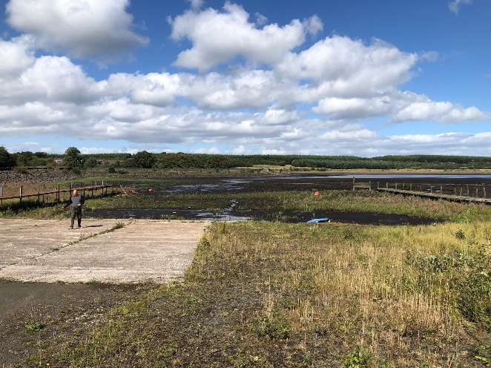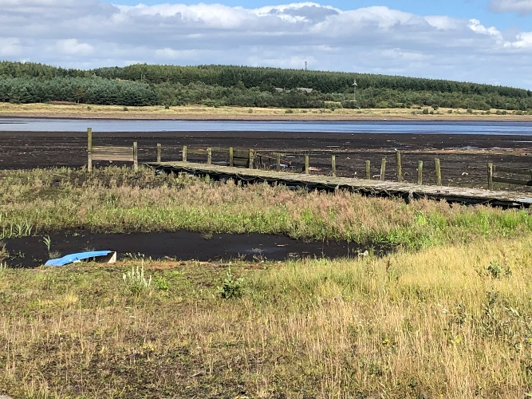

More News

Boat Maintenance
The pace of work is picking up now that I am more mobile after my injury in February. “Happy Days 11” has had her top deck repainted. The two sponsons have been sanded/repaired and undercoated. Also, the re-sited the tiller and then added a fairlead and block to guide the mainsheet.
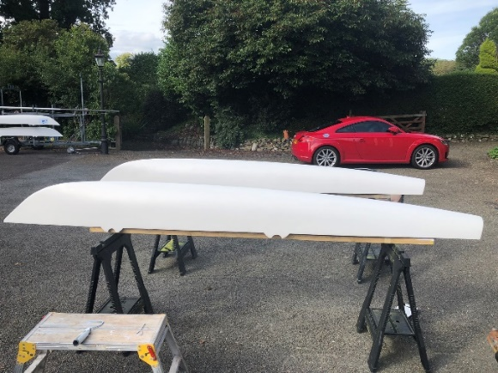 | 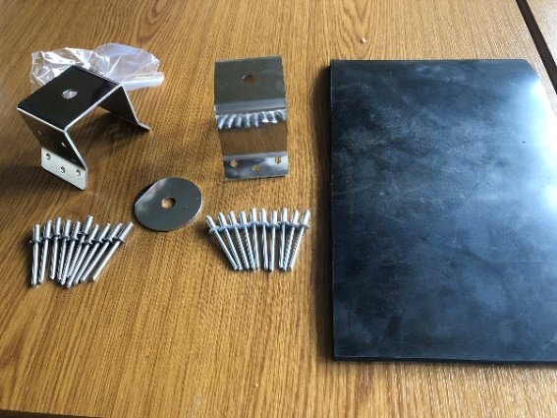
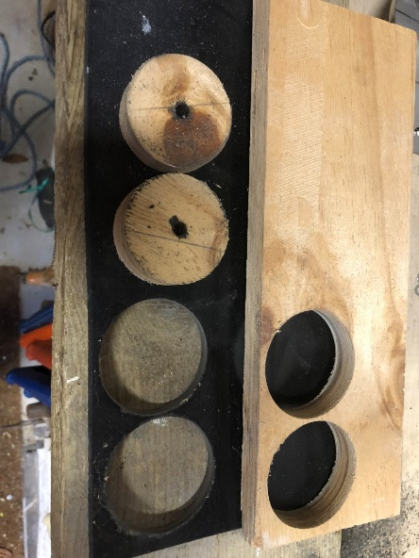 | 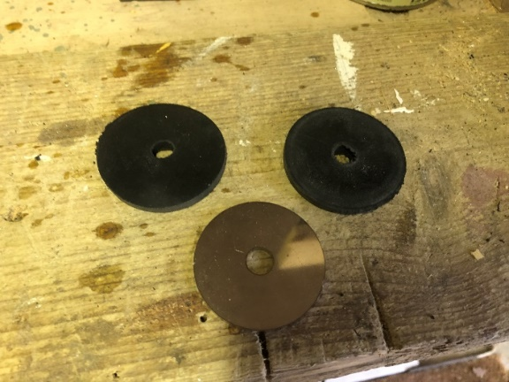
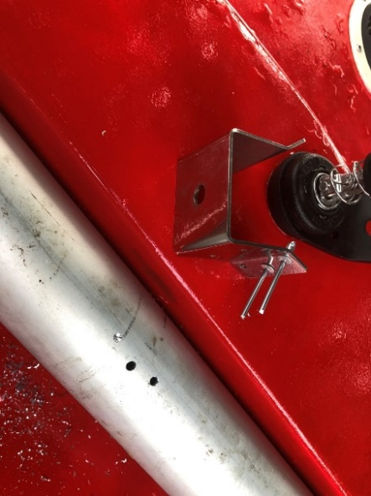 | 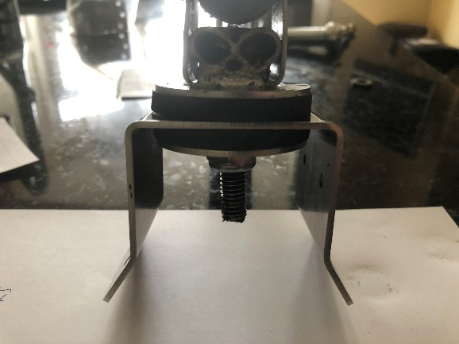
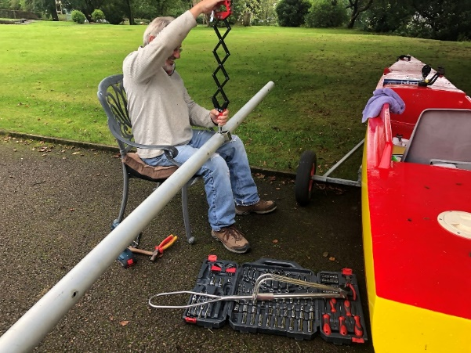 | 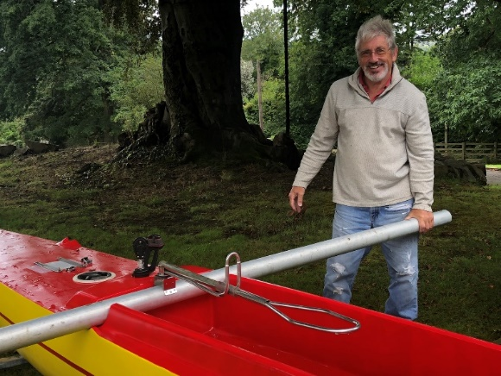

The sanding and revarnishing of the centreboard, which also required extensive epoxy resin repair work has been completed. After consulting with the committee, it was agreed that a new rudder and stock should be ordered for this boat. Plus all new sheets. She will look like new! Then just two more challengers to bring back to life.

Finally
I know it is only just August but in approximately 8-month time I will reach the end of my 4 year term as a trustee and will have to step down at our next AGM.
It is my responsibility to do all I can to make sure that the charity to survives. To this end the committee have agreed that an Extraordinary General Meeting (EGM) needs to be held later this year to effect some changes to the constitution. In broad terms the changes we will ask the members to vote on will enable the term a trustee is allowed to serve be increased from 4 years to 6 years. The exact wording of this proposal will be forwarded to members in plenty of time. Two justifications exist for this proposal.
- In order the Charity does not collapse at the next AGM through lack of Trustees.
- Because of Covid-19 it can be argued that as no sailing took place for almost two years the Trustees had very little they could do.

Steve Laycock
Chairman
Sailability Scotland SCIO

